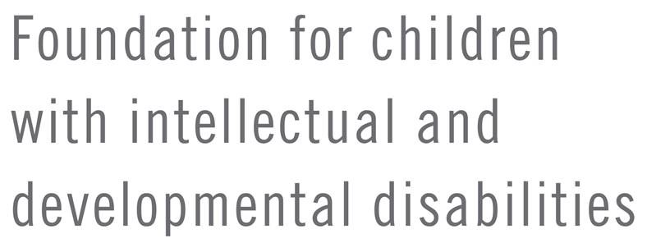
NEW MEMBER INCENTIVE
GRANT PROCESS

junior civitan club

Our Foundation is currently providing an opportunity for any Chesapeake District Junior Civitan to earn the right to designate a $50 grant to be awarded to the Civitan International Research Center (CIRC) on behalf of their school’s club to be designated toward either Sno-Do or Dance-a-Thon donations, or split between the two for the current Junior Civitan fiscal year.

This “New Member Grant” is available for sponsors of new members into any established Chesapeake District Junior Civitan club. Sponsors of charter members into newly established clubs are not eligible.

This privilege will be earned by the successful sponsorship of a new Junior Civitan member. To be a successful Junior Civitan, the sponsor should assist by an introduction of the new Junior Civitan to all members of the club, assist the new member to become a member of the Creed Club, review committees, and invite the new member to become a member of a committee(s).

To qualify for a “New Member Grant” the following criteria must be fulfilled:
- Parent and Member signed Membership Application completed and filed with Club and District Chair
- Parent and Member signed Photo release form completed and filed with Club and District Chair
- New member’s dues must be paid
- The Member will attend a formal Initiation Ceremony
- The Member will become a member of the Creed Club
- The Member will attend at least 4 Junior Civitan Club Meetings and/or Service Projects within the first two quarters as a new member
- Application form designating sponsor’s preference for grant distribution to be completed and signed by Club President and District Chair.

Upon successful completion of all requirements, one copy of the following forms must be completed and submitted to the Foundation President:
- New Member Incentive Grant Certification form (Revised 12/2/2015)
- Application for Grant (Revised 11/13/2015)*
The eligibility period to apply for Junior Civitan New Member Grant funds for sponsors of members joining in the first 3 quarters (July through March) of the current Junior Civitan fiscal year (July 1 – June 30) will expire on June 1st. Eligibility for members joining in the 4th quarter (April, May, June) will not expire until June 1st of the following fiscal year.

Funding for the FY16 Pilot Program has been capped. Once that maximum has been reached, you will be notified that the program has ended for the year. Only complete grant requests will be accepted and consideration will be on a first-come, first-served basis. Incomplete applications will be returned.

New Member Grants will not be awarded without all required documentation.

* The Grant Application form must be included for all grants disbursed by the Foundation for Children with Intellectual and Developmental Disabilities Chesapeake District – Civitan International, Inc. in order to continue to operate as a public funded corporation.

